Lesson 8: Performing Advanced Analytics using Trends, Clustering, and Forecasting
a) Add and interpret trend lines (linear, exponential)
b) Customize and analyse trend models
c) Perform clustering on datasets
d) Analyse distributions using built-in tools
e) Apply forecasting techniques
f) Compare different statistical models
g) Export and interpret statistical results
A: Add and Interpret Trend Lines (Linear, Exponential)
1. Connect Dataset & Build a Scatter Plot / Line Chart
1. Open Tableau Desktop and load Indian_Climate_Dataset_2024_2025.csv.
2. Open a new worksheet and rename it to Temperature vs Humidity Trends.
3. Drag Humidity (%) to the Columns shelf.
4. Drag Temperature_Avg (°C) to the Rows shelf.
5. In the top menu, go to Analysis and uncheck Aggregate Measures (so each data point is plotted individually rather than summed up).
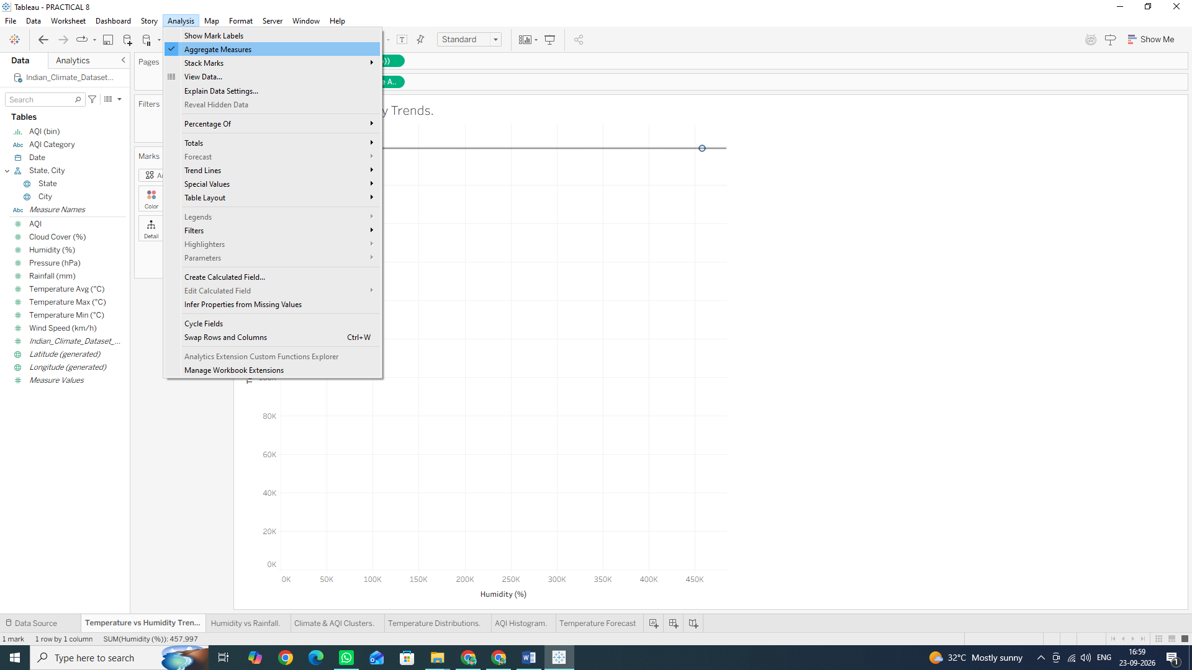

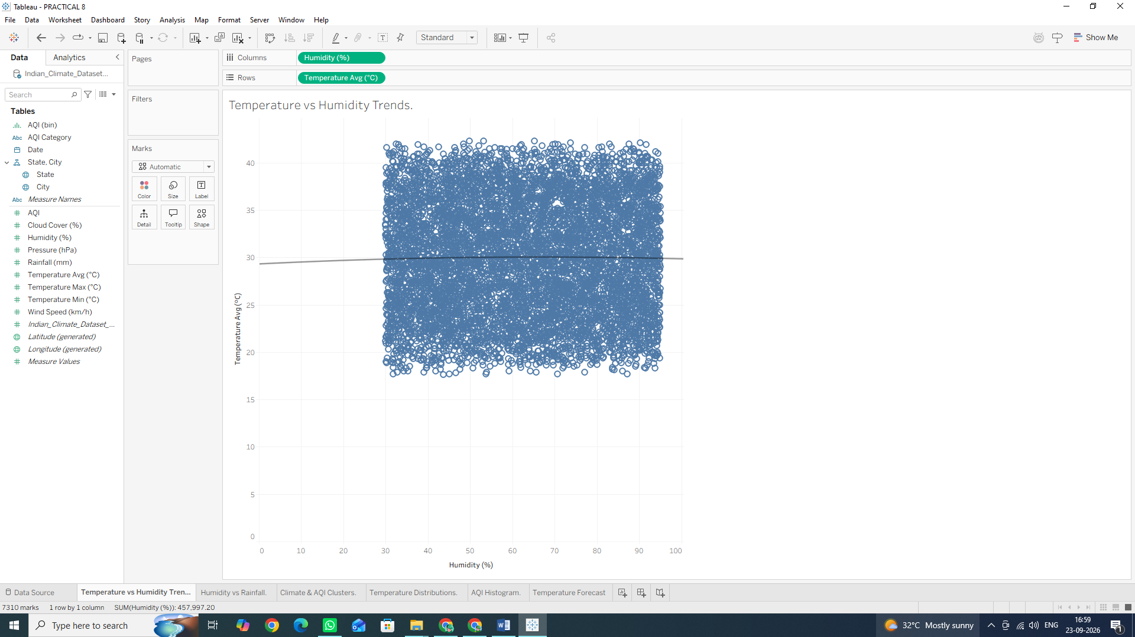
2. Add a Linear Trend Line
1. Switch to the Analytics pane on the left sidebar (tab next to Data).
2. Under Model, drag Trend Line onto the canvas and drop it onto Linear
3. Hover over the trend line to observe the statistical popup:
- It displays the linear equation: Temperature_Avg = a x Humidity + b
- It displays R2 (coefficient of determination) and P-value (statistical significance).
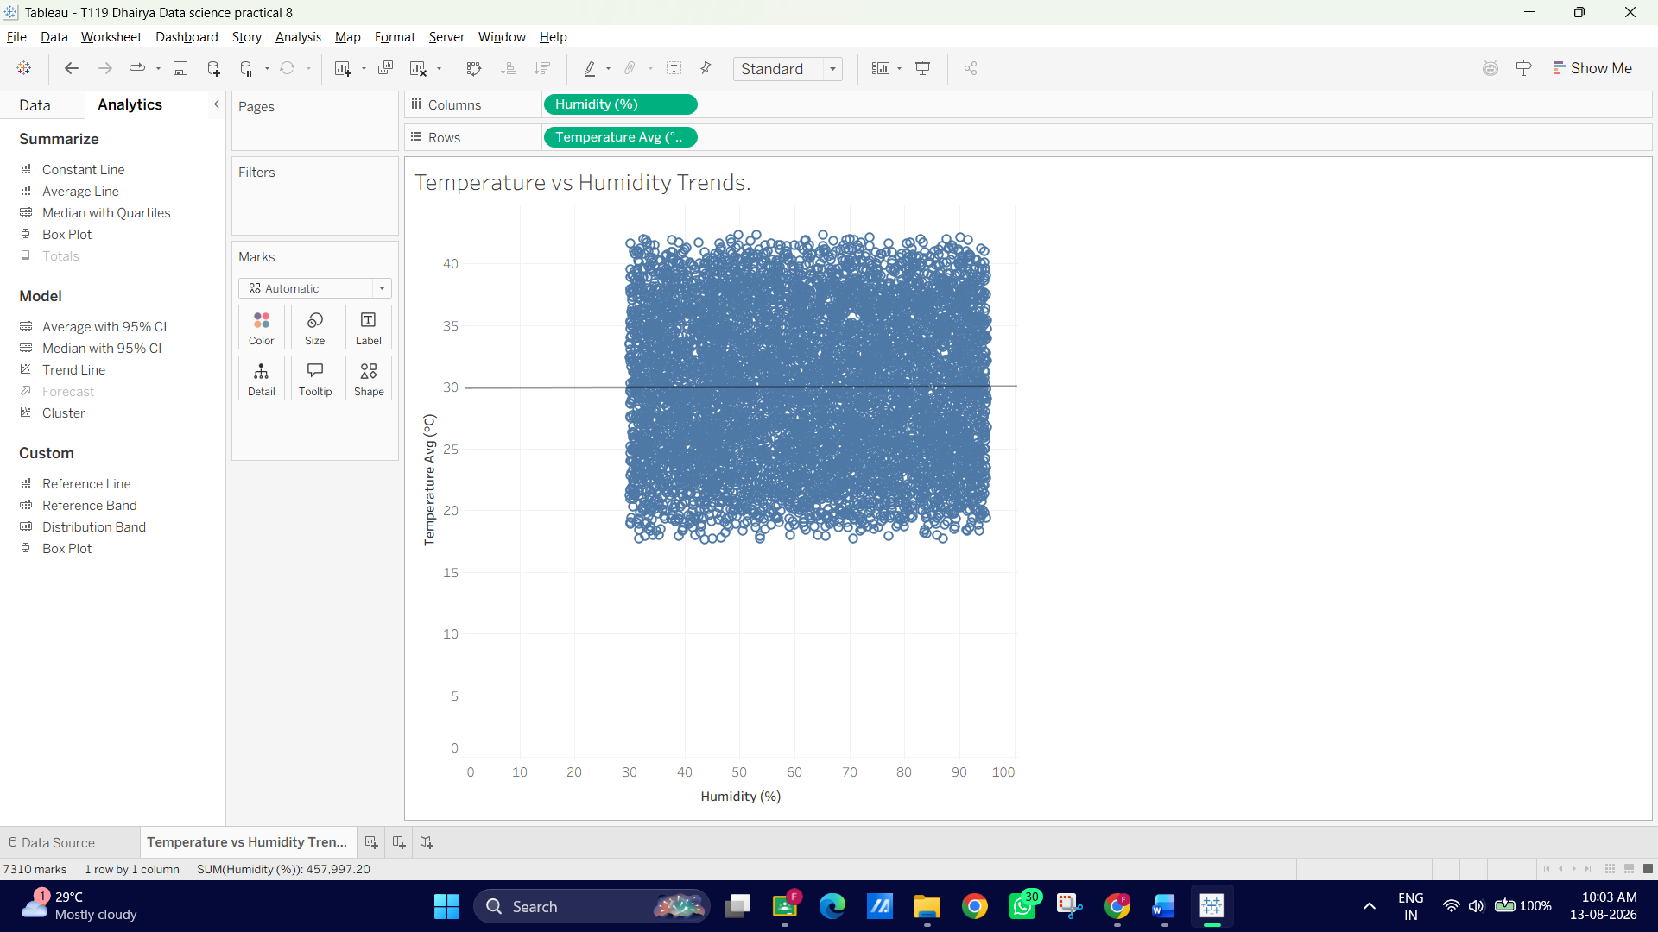
3. Add an Exponential Trend Line for Non-Linear Measures (Rainfall vs. Humidity)
1. Open a new worksheet named Humidity vs Rainfall.
2. Drag Humidity (%) to Columns and Rainfall (mm) to Rows.
3. Uncheck Analysis ◊ Aggregate Measures.
4. From the Analytics pane, drag Trend Line onto Exponential (or right-click the canvas ◊ Trend Lines ◊ Show Trend Lines ◊Edit Trend Lines and change the model to Exponential).
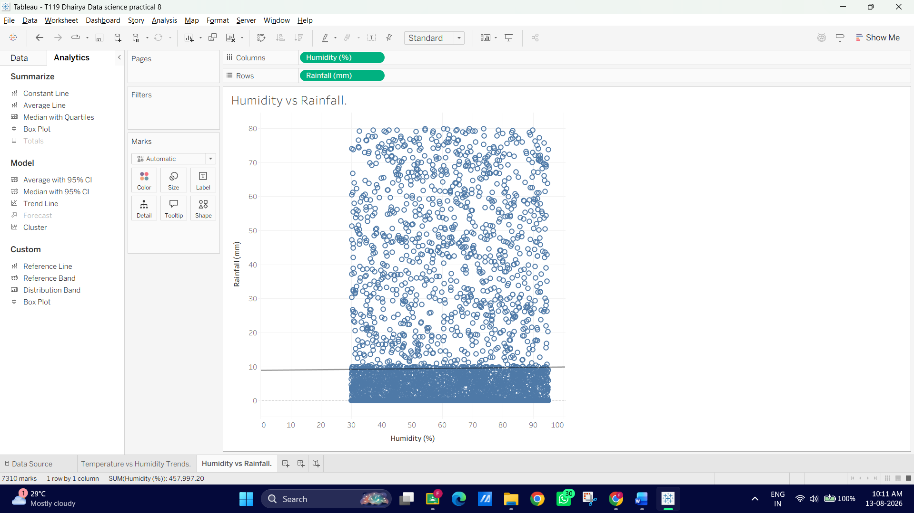

4. Interpret the Results
- Linear Model: Describes direct proportional/inverse relationships (e.g., checking if higher humidity steadily decreases or increases average temperature).
- Exponential Model: Captures accelerating relationships (e.g., how rainfall spikes exponentially once humidity crosses higher thresholds).

B: Customize and Analyse Trend Models
1. Disaggregate Trend Lines by City
1. Open your Temperature vs Humidity Trends sheet from Part A (or create a duplicate). 2. Drag City from the Data pane onto Colour on the Marks card.
- Notice what happens: Instead of one global trend line, Tableau automatically computes 10 distinct trend lines, one for each city!
3. Observe how coastal cities (like Mumbai or Chennai) show different slopes compared to inland cities (like Delhi or Jaipur).
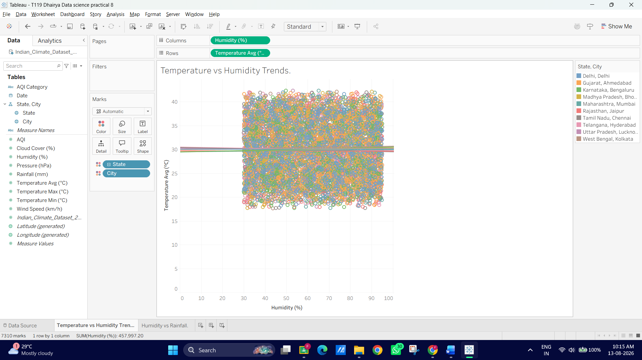
2 Compare Different Model Types (Polynomial & Logarithmic)
1. Right-click on any trend line in the view and select Edit Trend Lines...
2. In the options dialog, experiment with switching the Model Type:
- Linear: Assumes a constant rate of change.
- Logarithmic: Useful when values rise rapidly at first and then level off.
- Polynomial (Degree 2 or 3): Great for U-shaped or S-shaped seasonal curves (e.g., temperatures dipping mid-year and rising again).
3. Select Polynomial (Degree 2) and click OK to observe how well a curved line fits seasonal fluctuations.
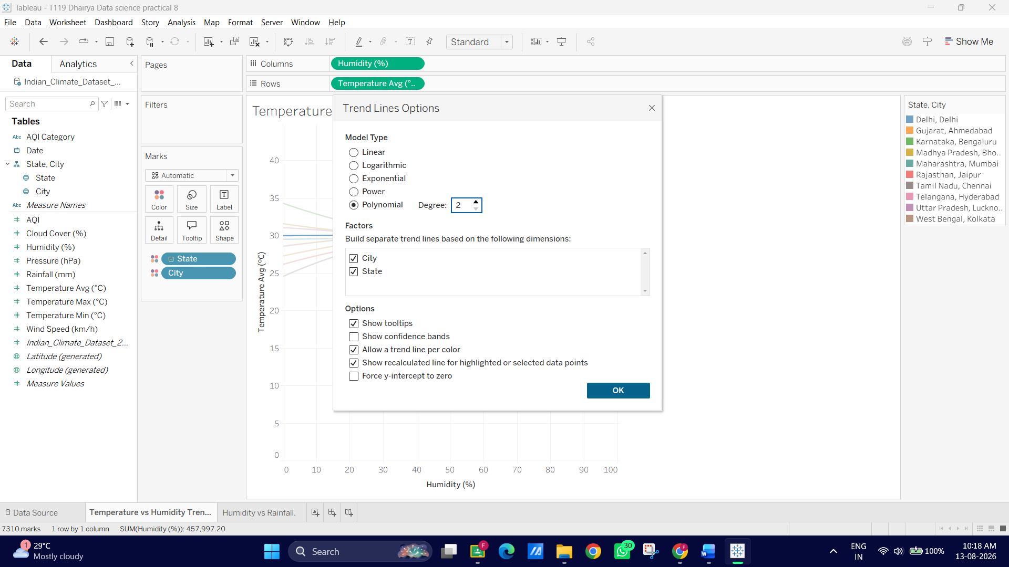
3. Access Full Statistical Summaries (Describe Model)
1. Right-click anywhere on the chart background or trend line and select Describe Trend Line...
- This shows a quick overview of formula equations, R 2 and P-value per city.
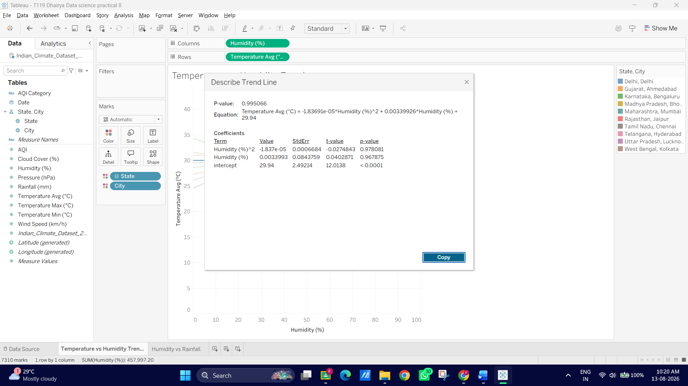
2. Next, right-click and select Describe Trend Model...
- A detailed window will pop up showing the ANOVA table, Degrees of Freedom, Sum of Squared Errors (SSE), and F-statistic.
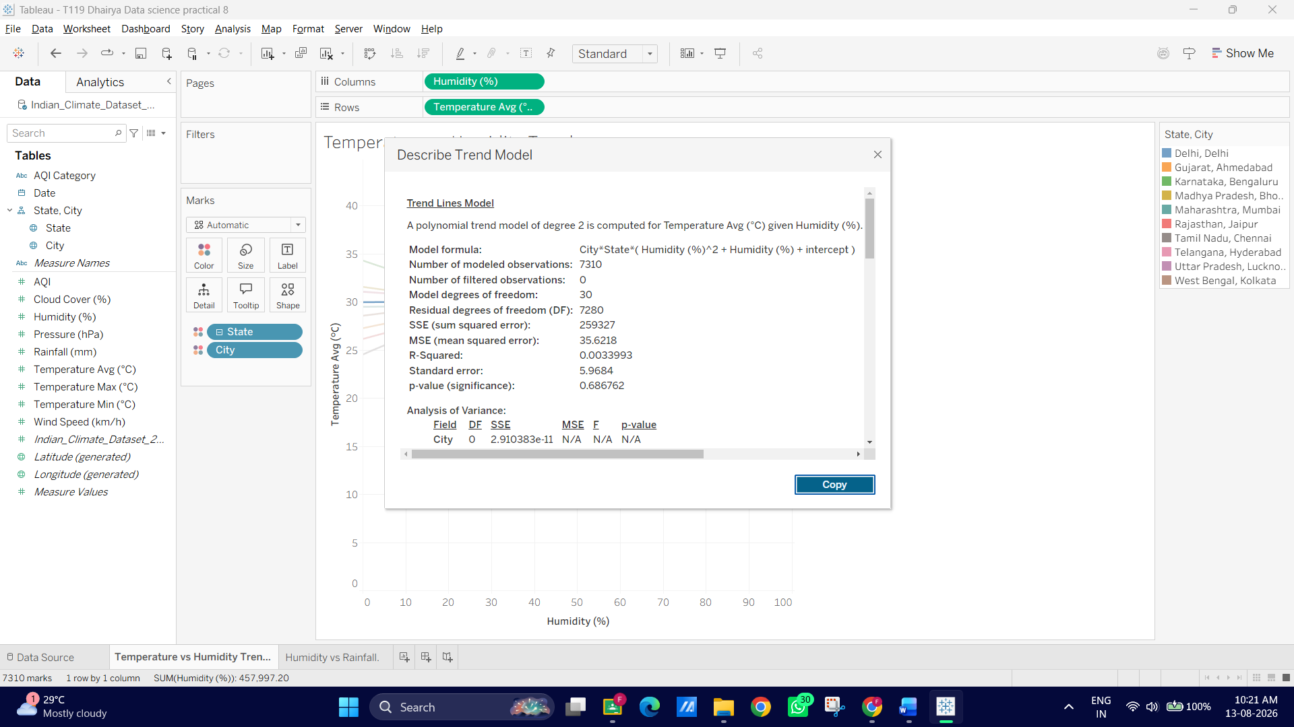
3. Review these metrics to see which city's model explains the highest variance (R2)
C: Perform Clustering on Datasets
1. Build a Multi-Metric Scatter Plot Matrix
1. Open a new worksheet and name its Climate & AQI Clusters.
2. Drag AQI to Columns.
3. Drag Temperature_Avg (°C) to Rows.
4. In the top menu, go to Analysis and uncheck "Aggregate Measures".
5. Drag City to Detail on the Marks card (so points represent individual city-day observations).
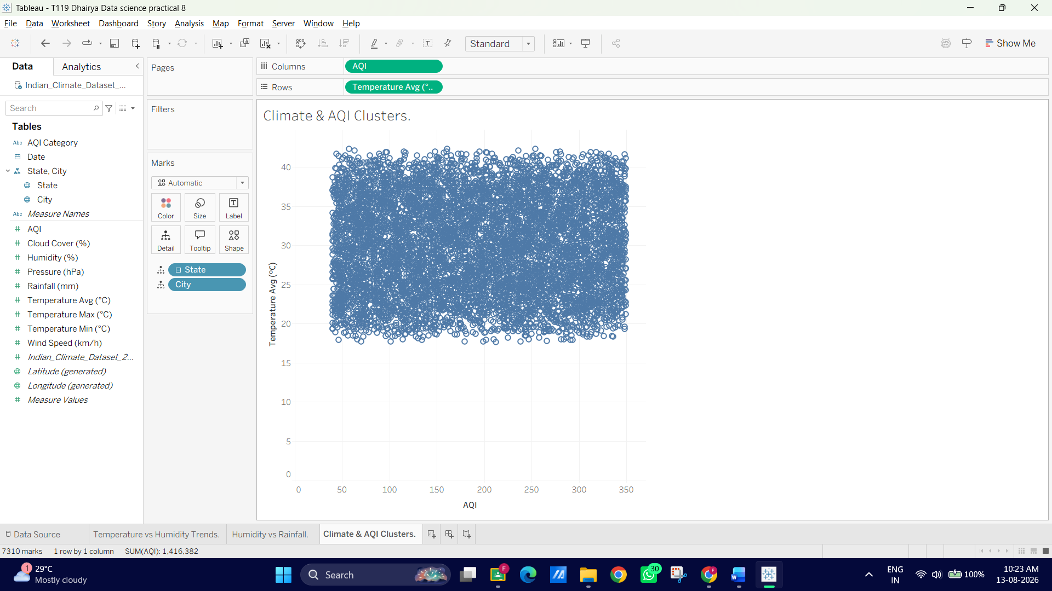
2.Apply Built-in Tableau Clustering
1. Switch to the Analytics pane on the left sidebar.
2. Under Model, drag Cluster directly onto the canvas.
3. A Clusters dialog box will appear on the right side of the view.
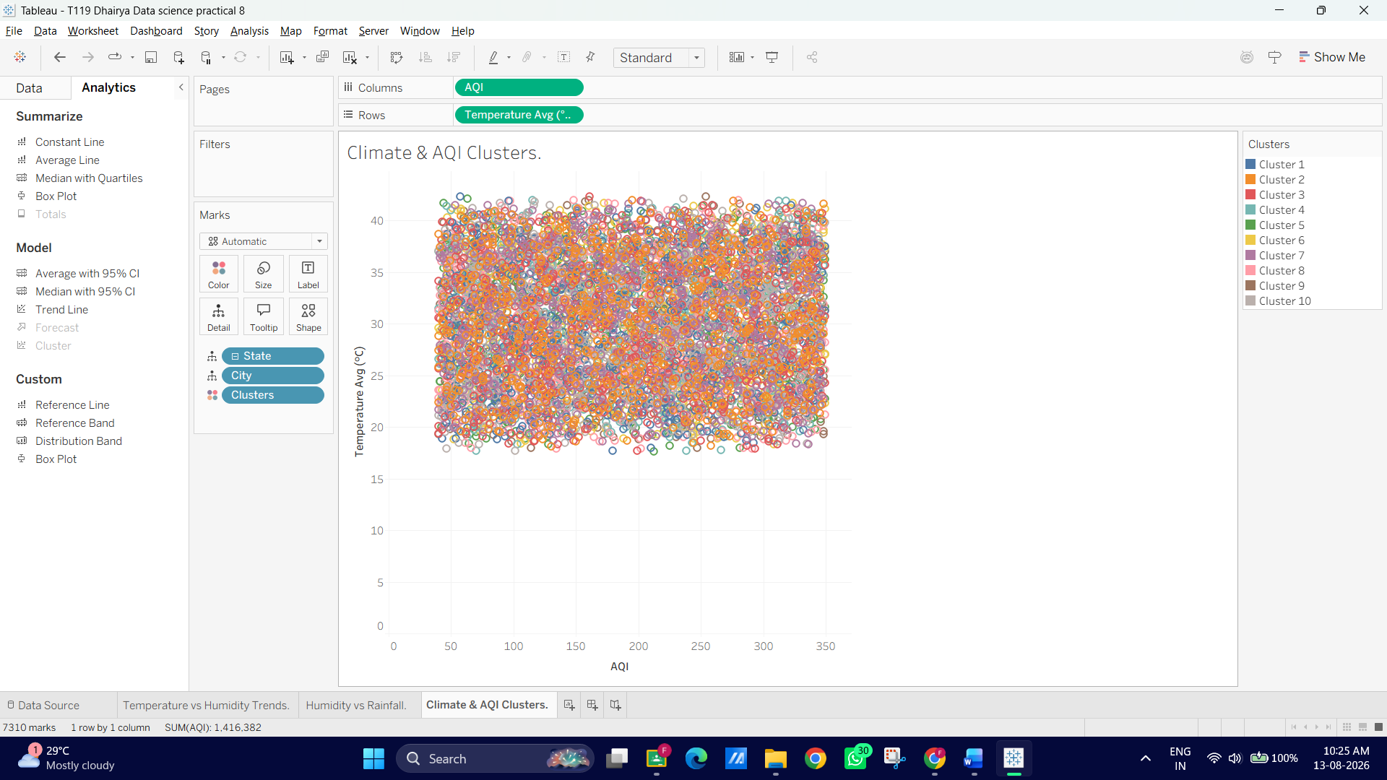
4. Drag additional variables into the Variables box to create a multi-variable cluster model (If you can’t find Variable box Right Click Clusters in Marks Card, click on Edit Clusters and drag and drop the variables on the box):
- AQI
- Temperature_Avg (°C)
- Humidity (%)
- Wind_Speed (km/h)
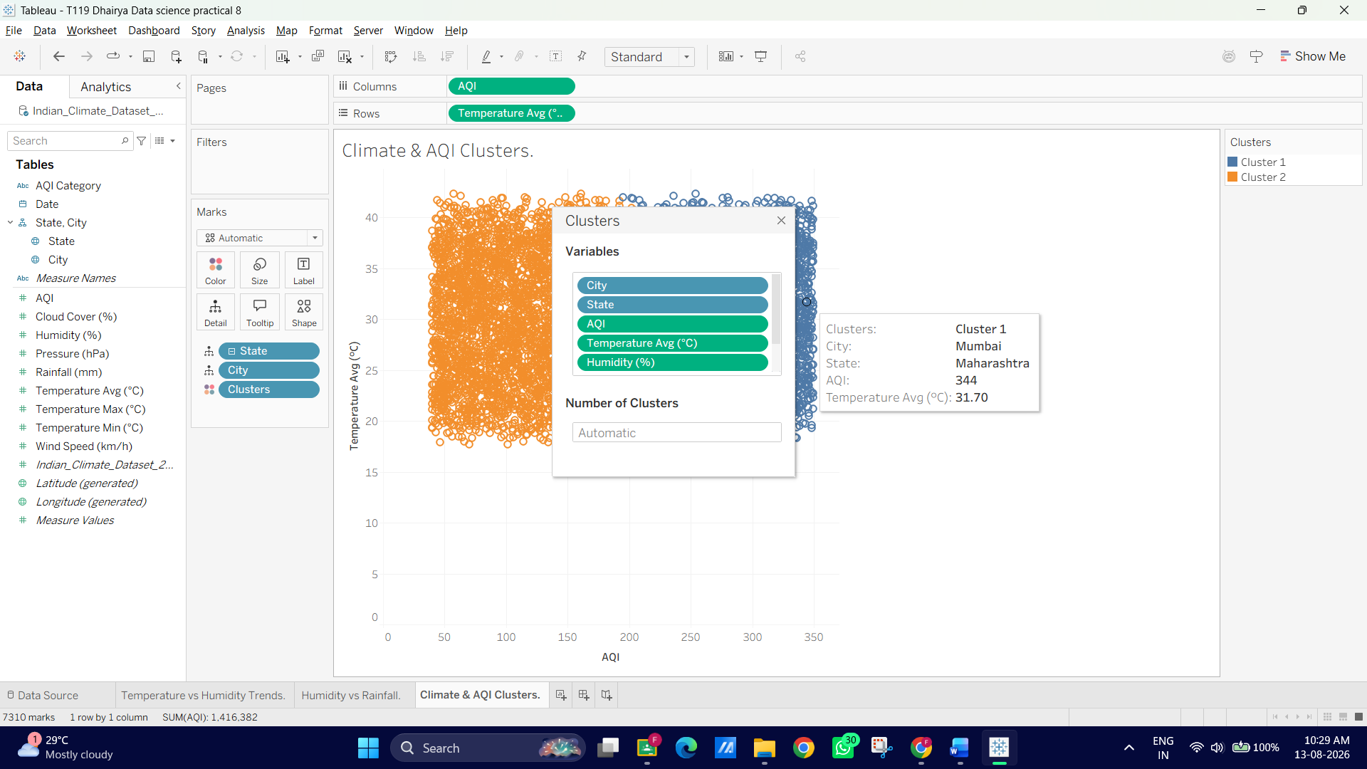
5. Under Number of Clusters, leave it as Automatic (Tableau will calculate the optimal number using K-means), or type 3 or 4 to explicitly create 3 or 4 distinct climate groups.
6. Close the cluster popup window. Tableau will color-codes every data point by its assigned cluster (e.g., Cluster 1, Cluster 2, Cluster 3).
3. Analyse Cluster Profiles & Save as Dimension
1. Right-click on the Clusters field in the Marks card (or legend) and select Describe Clusters...
2. In the popup window, review two key tabs:
- Summary: Shows the mean value of each metric (AQI, Temperature, Humidity, Wind Speed) for each cluster.
- Models: Shows ANOVA statistics (F-statistics and p-value) indicating which variables contributed most heavily to separating the clusters.

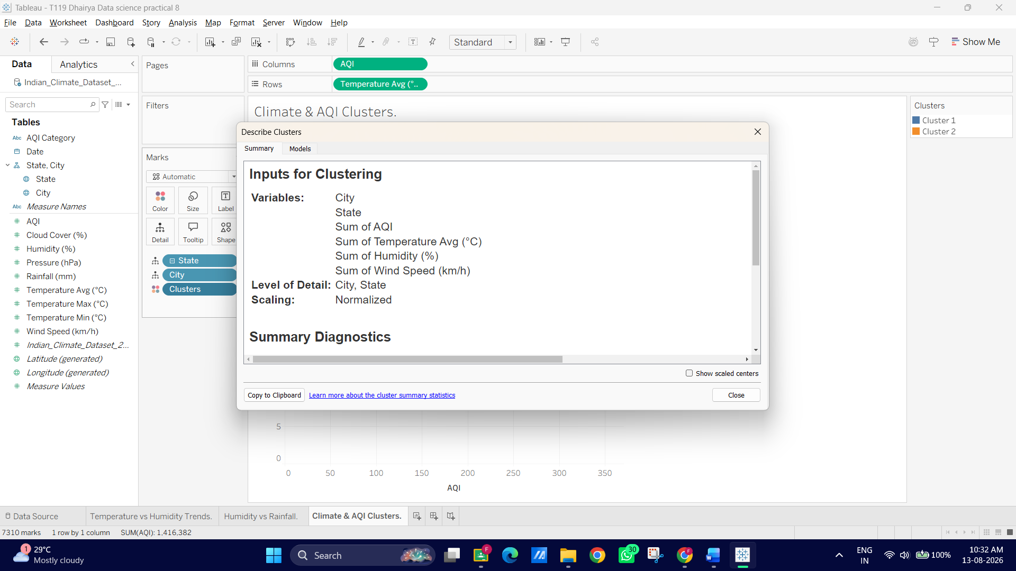
D: Analyse Distributions using Built-in Tools
1. Create a Box Plot for Temperature Distributions by City
1. Open a new worksheet and name it Temperature Distributions.
2. Drag City to Columns.
3. Drag Temperature_Max (°C) to Rows.
4. Tableau will default to SUM(Temperature_Max). Right-click the Temperature_Maxpill on Rows ◊ Measure (Sum) ◊change it to Dimension (or go to Analysis menu and uncheck "Aggregate Measures").
5. Switch to the Analytics pane on the left sidebar.

6. Under Custom, drag Box Plot onto the canvas and drop it on the chart.
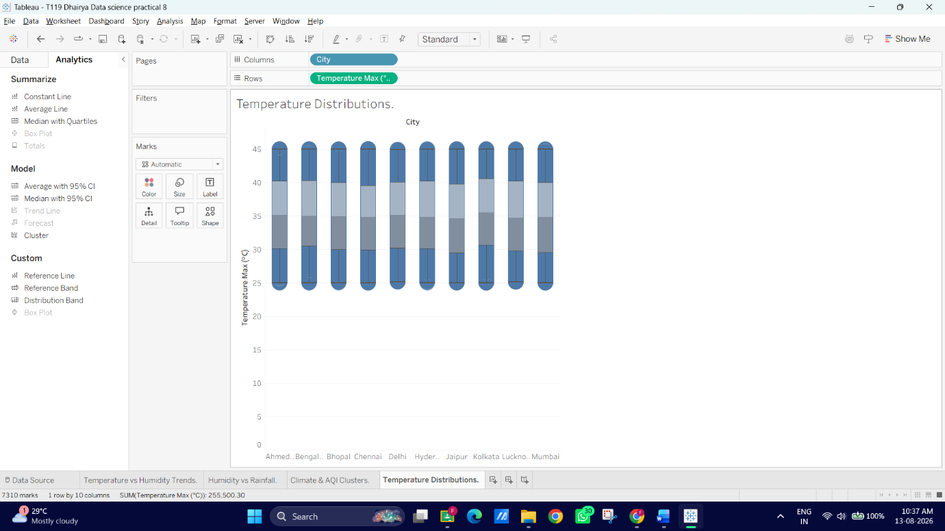
7. Hover over any box plot to inspect key statistical metrics:
- Upper Whisker / Maximum: Upper fence boundary.
- Upper Hinge (Q3): 75th percentile.
- Median (Q2): 50th percentile.
- Lower Hinge (Q1): 25th percentile.
- Outliers: Individual points plotted beyond the whiskers.
2. Build an AQI Histogram & Quantile/Percentile View
1. Open a new worksheet named AQI Histogram.
2. From the Data Pane, click on AQI.
3. Open the Show Me panel in the top-right corner of Tableau
4. Select the Histogram icon. (Tableau will automatically create an AQI (bin) dimension and place AQI (bin) on Columns and CNT(AQI) on Rows).
5. Drag City to Color on the Marks card to see how air quality distributions stack across cities.
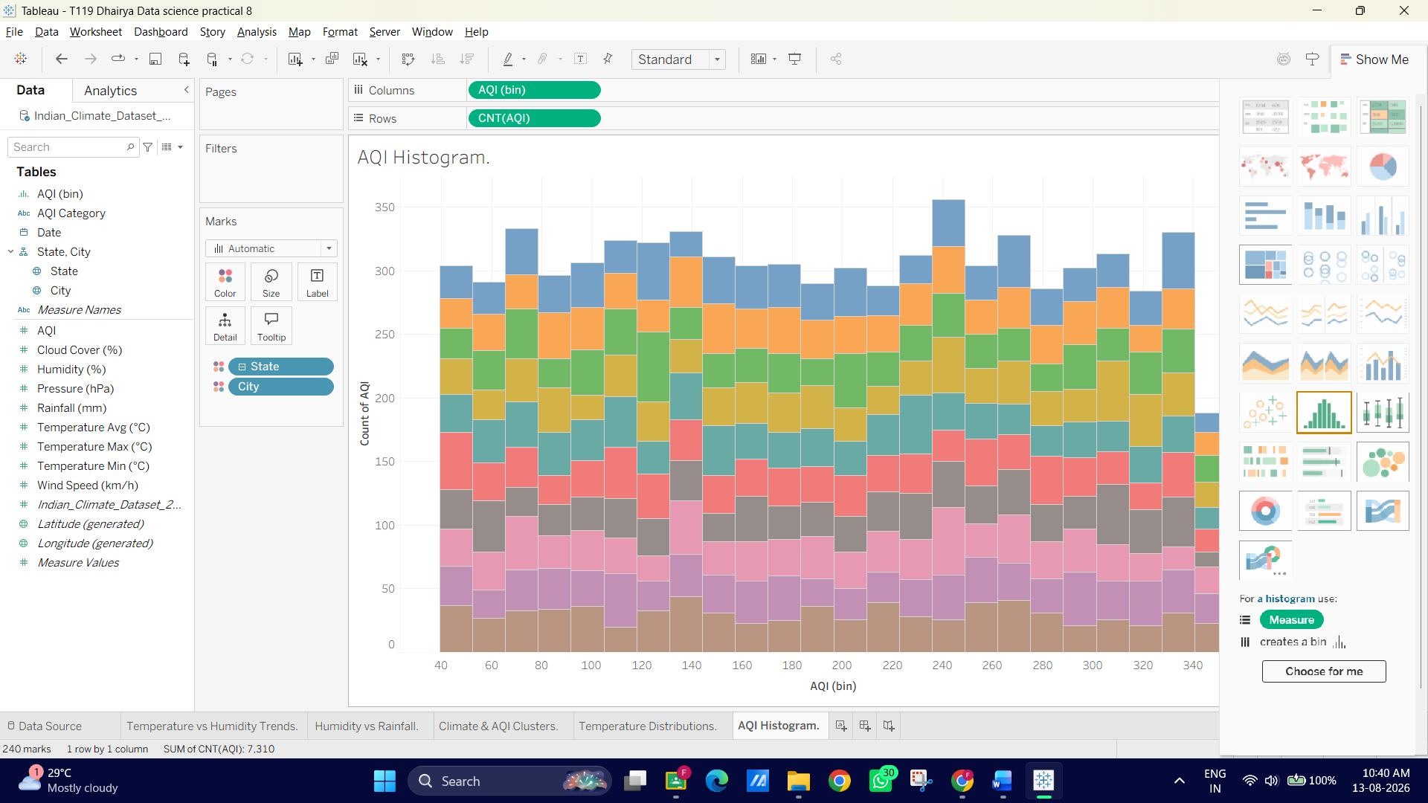
E: Apply Forecasting Techniques
1. Set Up a Time Series Line Chart
1. Open a new worksheet and name it Temperature Forecast.
2. Drag Date to Columns.
- Note: Tableau will default to YEAR(Date). Click the dropdown arrow on the Datepill and change it to continuous Month (the second Month option in the menu, which displays as Month Year, e.g., May 2024).
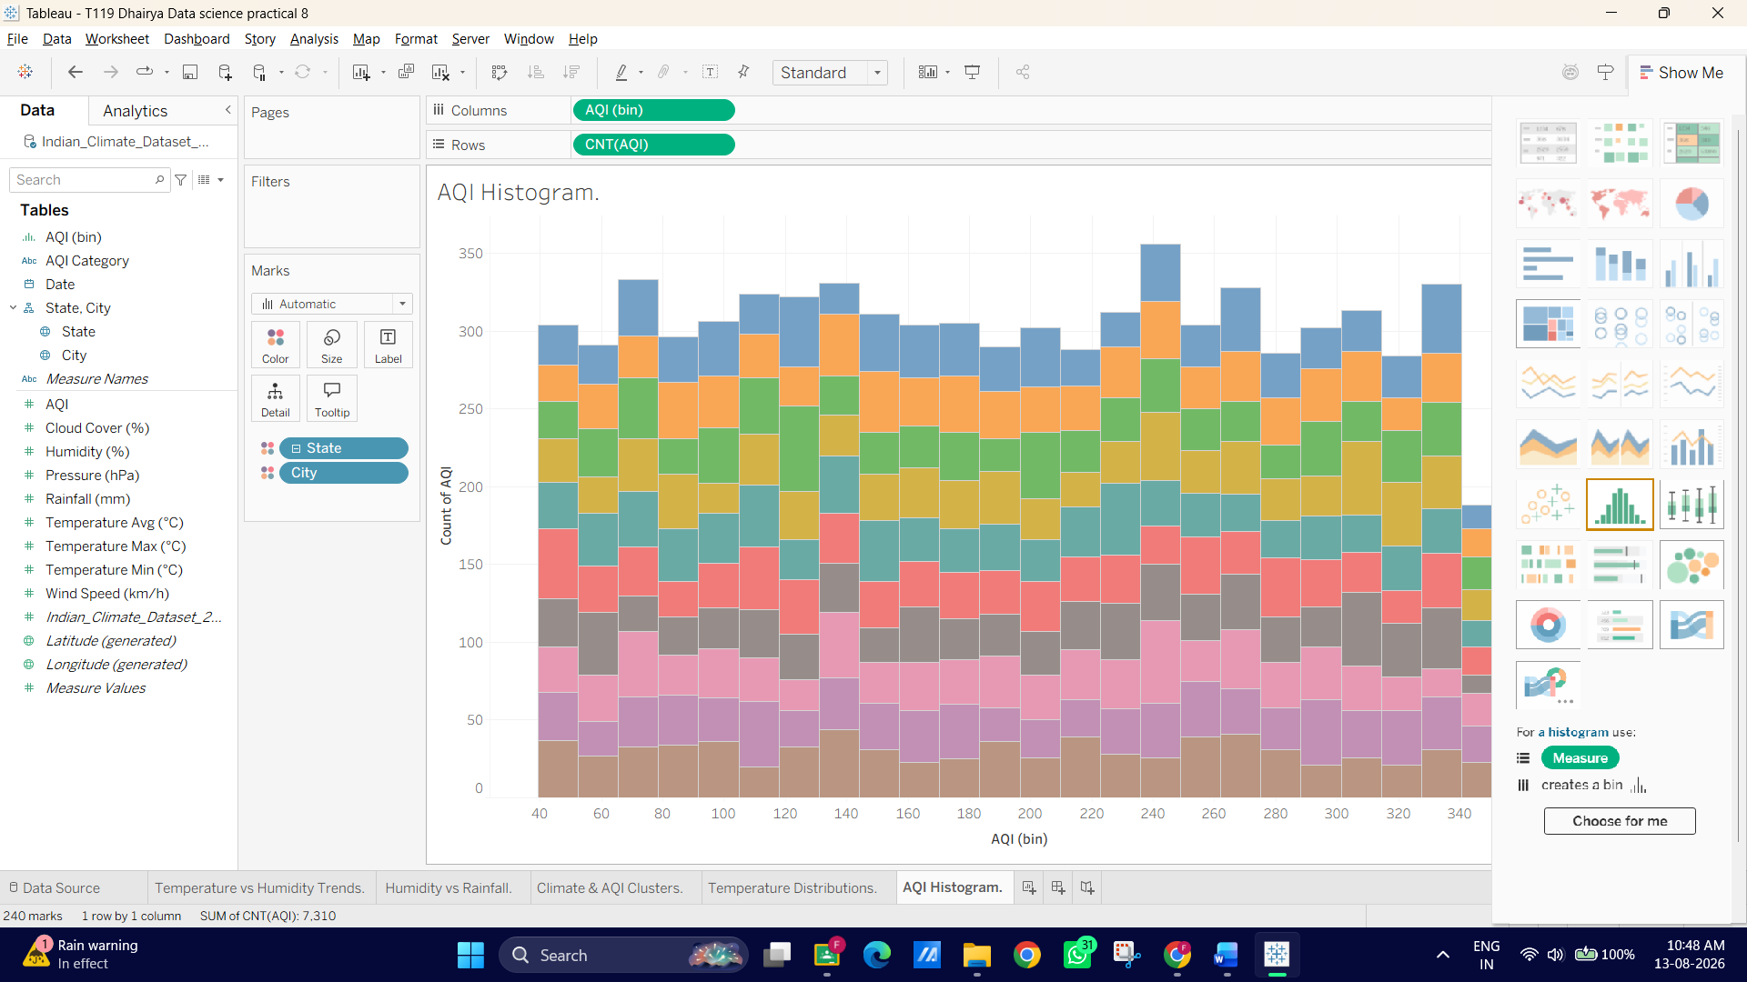
E: Apply Forecasting Techniques
1. Set Up a Time Series Line Chart
1. Open a new worksheet and name it Temperature Forecast.
2. Drag Date to Columns.
- Note: Tableau will default to YEAR(Date). Click the dropdown arrow on the Datepill and change it to continuous Month (the second Month option in the menu, which displays as Month Year, e.g., May 2024).
3. Drag Temperature_Max (°C) to Rows (ensure it is set to AVG(Temperature_Max)).
4. Drag City to Filters and select 2 or 3 cities (e.g., Mumbai, Delhi, Bengaluru) to keep the view clean.
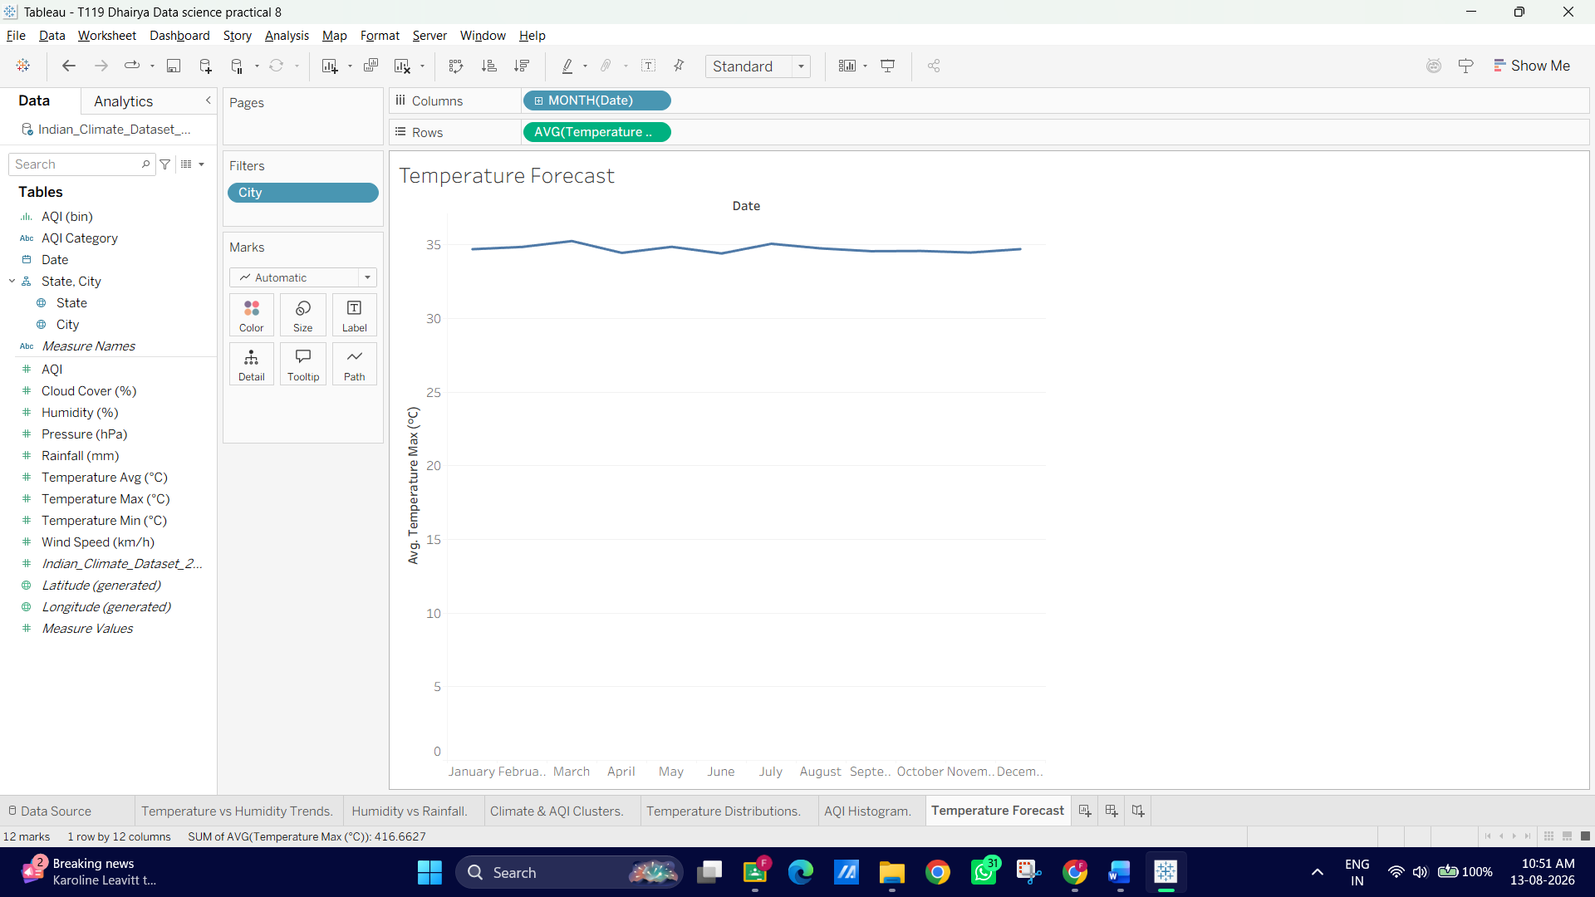
2. Enable Tableau Forecasting
1. Switch to the Analytics Pane on the left sidebar.
2. Under Model, drag Forecast onto the canvas and drop it
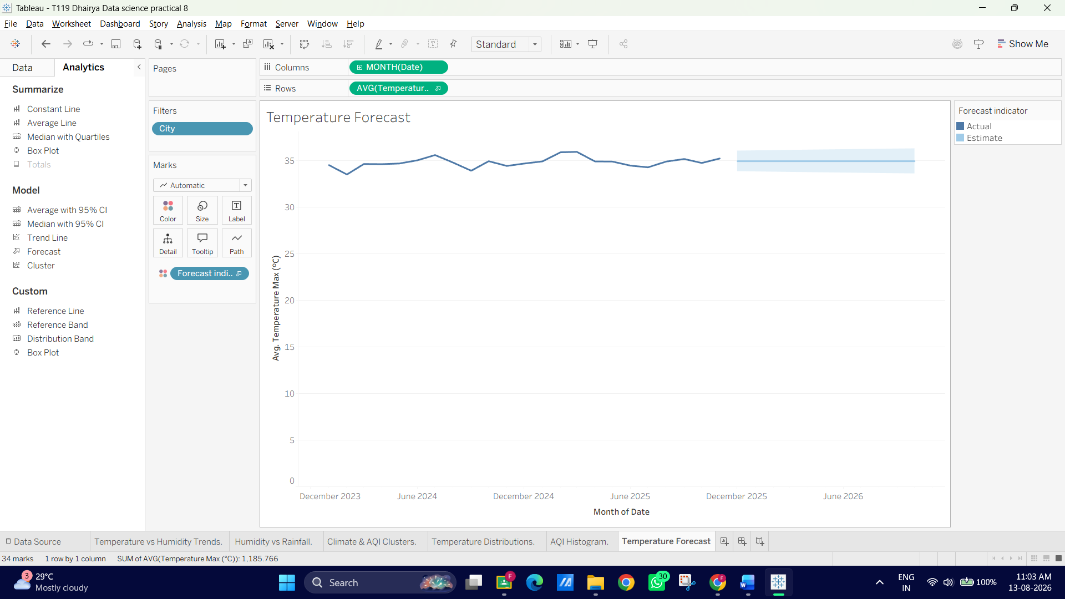
3. Tableau will instantly extend the line chart into the future with a shaded prediction interval band!
3. Customize & Analyze the Forecast
1. Right-click anywhere on the chart canvas ◊ select Forecast ◊Forecast Options....
2. Under Forecast Length, set it to Exactly 6 Months into the future.
3. Under Prediction Interval, verify it is set to 95%
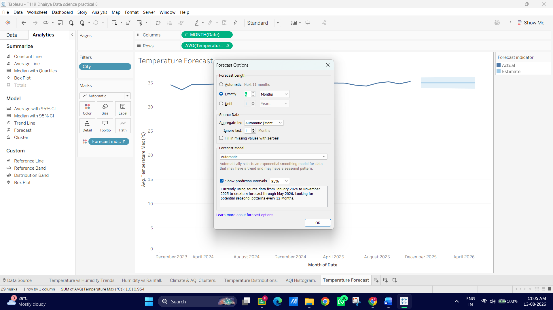
4. To evaluate the mathematical quality of the forecast:
- Right-click the chart -◊ Forecast ◊Describe Forecast....
- Review the Models tab to check metrics like the Root Mean Squared Error (RMSE) and whether Tableau selected an Additive or Multiplicative model for trend and 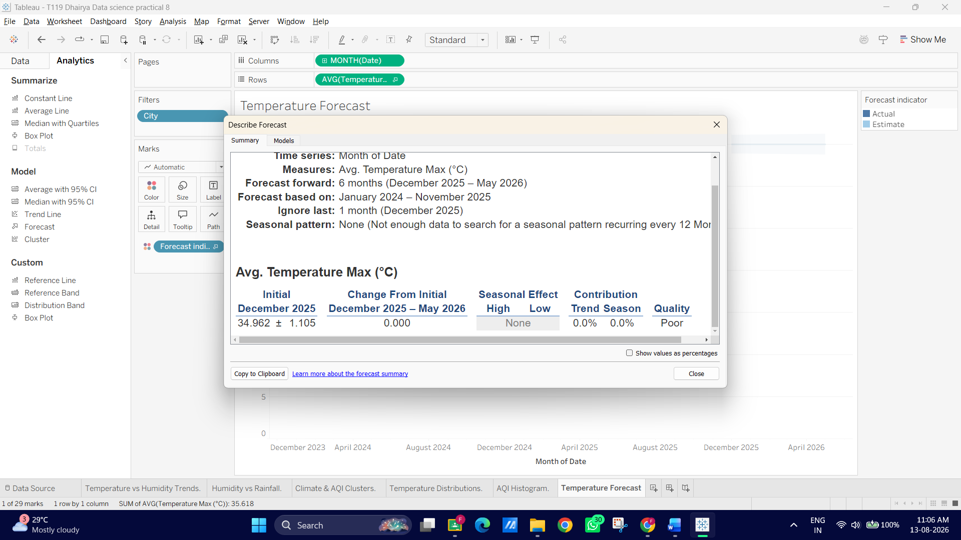
F: Compare different Statistical Models
1. Set Up the Comparison View
1. Open a new worksheet named Model Comparison.
2. Drag Temperature_Max (°C) to Columns (set to Continuous Dimension or AVG).
3. Drag AQI to Rows (set to Continuous Dimension or AVG).
4. Drag City to Detail on the Marks card to scatter plot individual city readings.
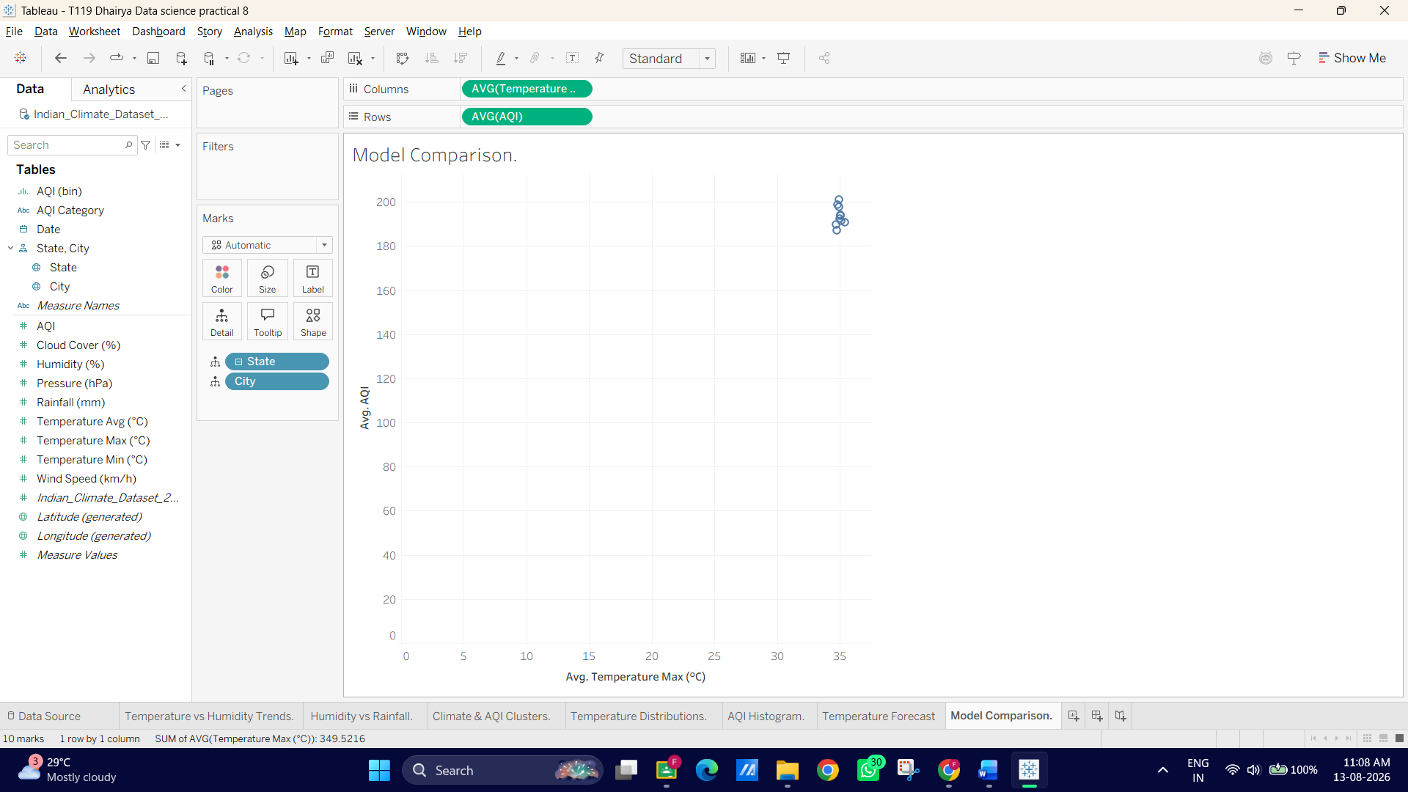
2. Add and Swap Statistical Models
1. Open the Analytics Pane on the left.
2. Drag Trend Line onto the canvas and drop it on Linear.
3. Hover over the trend line and note the R 2 and p-value.
4. Right-click the trend line ◊ Edit Trend Lines....
5. Switch the Model Type through the options:
- Linear
- Logarithmic
- Exponential
- Polynomial (Degree 2 or 3): Fits curved relationships.
6. Compare the R 2 value for each model type. The model with the higher R2 and a p-value < 0.05 provides the best fit.
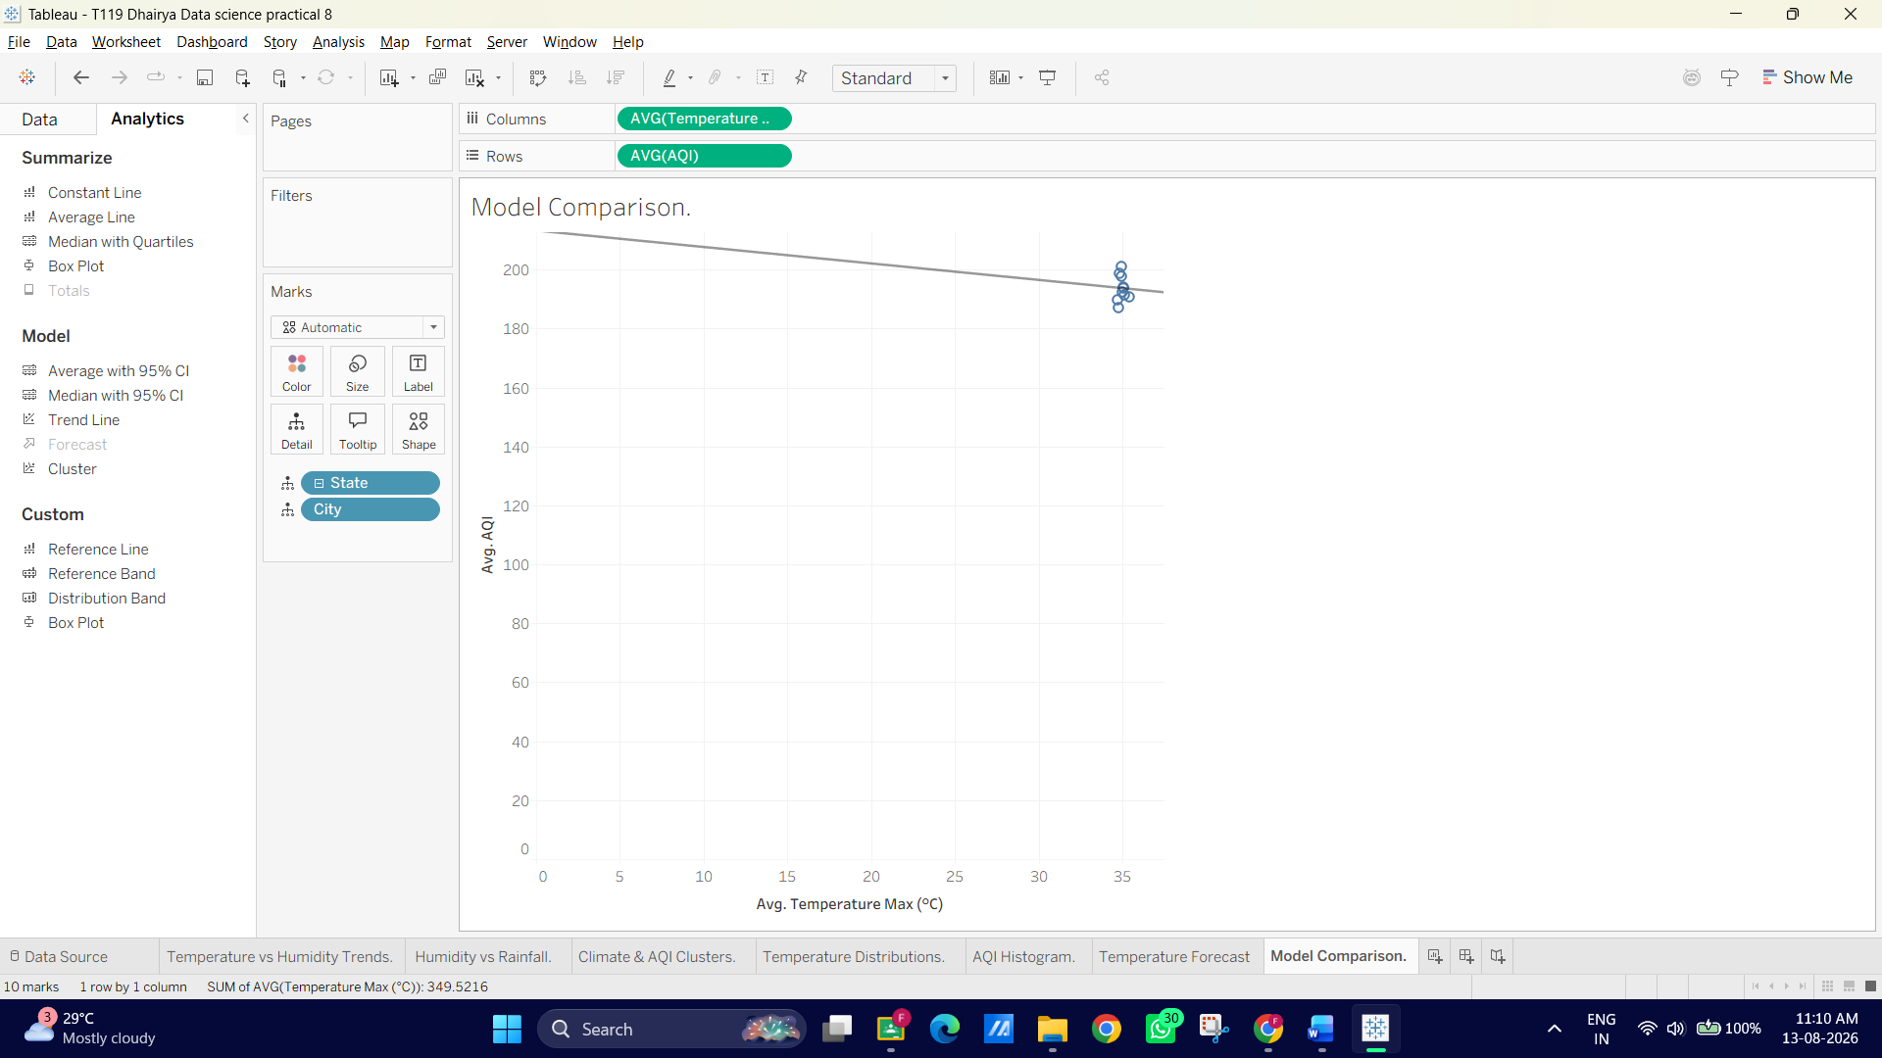
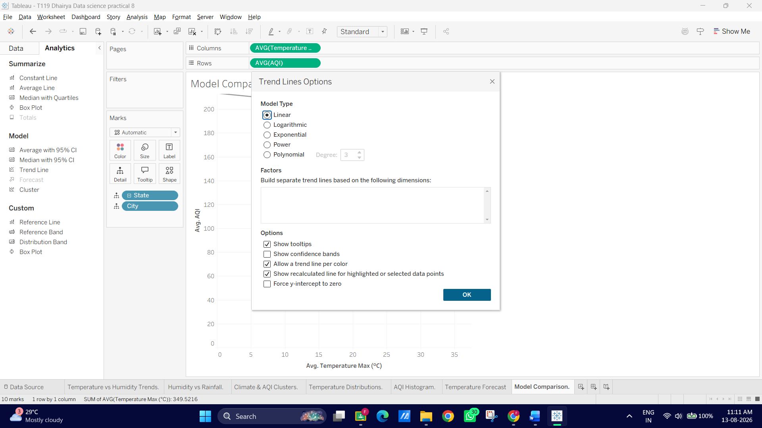
G: Export and Interpret Statistical Results
1. Export the Statistical Model Description
1. On your Model Comparison worksheet (or any trend/forecast sheet), right-click the trend line or canvas.
2. Select Describe Trend Model... (or Describe Forecast... if on a forecast sheet).
3. In the pop-up window, click Copy at the bottom (or click Export to save as a text file).
4. You now have the full ANOVA summary table and parameter estimates copied to your clipboard!
2. Interpret the Key Output Metrics
When reviewing or documenting your exported statistics, highlight these 3 core findings:
1. Equation Parameters: Look at the formula coefficients (intercept and slope). 2. R 2 Value:
- Example: An $R^2 = 0.74$ means $74\%$ of the variance in AQI is explained by Temperature changes.
3. p-Value: o A p-value < 0.0001 indicates the relationship is statistically significant (unlikely to occur by random chance).
